University of Maryland Global Campus

CMSC 495

Professor Kayed

Group 1

Gonghweh Koo

Scott Richardson

Cynthia Reynolds

Jonathan Dreksler

November 11, 2020

Project Design

Library Management System

Table of Contents

1. Overview 3

Background 3

2. Overall Approach 3

3. Implementation Design 4

3.1. High Level Class Diagram 4

3.2. Entity Class Diagram 5

3.3. Component Diagram 6

4. User Interface Design Mockups 6

4.1. Item Search 6

4.2. User Login 6

4.3. Search Result 7

4.4. Advanced Search 7

Version History

|  |  |  |  |
| --- | --- | --- | --- |
| Date | Version | Description | Team Member |
| 10-Nov | 0.1 | Initial draft | Gonghweh Koo |

# ****Overview****

## Background

The Library Management System (LMS) is an online application for assisting library users in accessing the assets in the library. The system provides a basic set of features to register new users, update personal information, search for library assets (e.g., books, DVDs), request and reserve library assets, and manage check-in and checkout processes.

# Overall Approach

The LMS will be using version 8 of the Java programming language for implementation. Because it will be using the latest version of a high-level language, the implementation will take advantage of the latest built-in API’s for input/output and data structures. The architecture of class definition will be based on object-oriented concepts and use design patterns such as data access objects and separation of concerns. The user interface will use Swing components in order to build a desktop GUI application. As part of the design process, we leveraged our familiarity with the local public library services and used their websites as a resource to determine the use cases for our application.

# Implementation Design

## High Level Class Diagram

The class diagram below demonstrates the main classes and interfaces that are used to implement the application. The ILibraryItem interface will have implementing classes that represent the main entities, such as books, movies, and so on, that are available at the library.

## Entity Class Diagram

The class diagram below shows in detail the types of entities this application will support. Each of the entities implement the ILibraryItem interface which defines a common set of properties applicable to each item that can be borrowed from the library.

## Component Diagram

The below diagram shows the execution flow between different components in the application. The classes have been designed to create separation of concerns between the user interface, the service layer that provides most of the business logic, and the data storage layer. In this application, we will be using a file to store the different data entities used in the application.

# User Interface Design Mockups

## Item Search

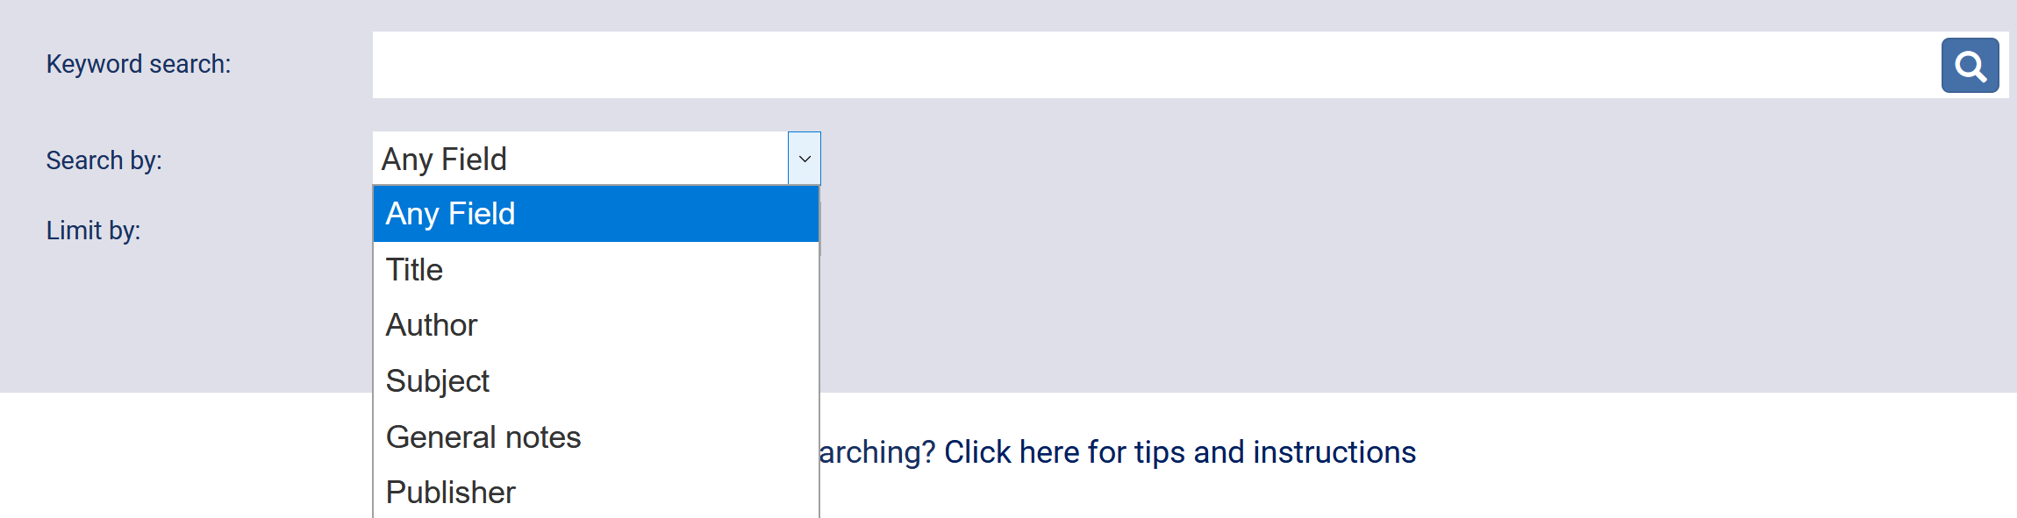

## User Login

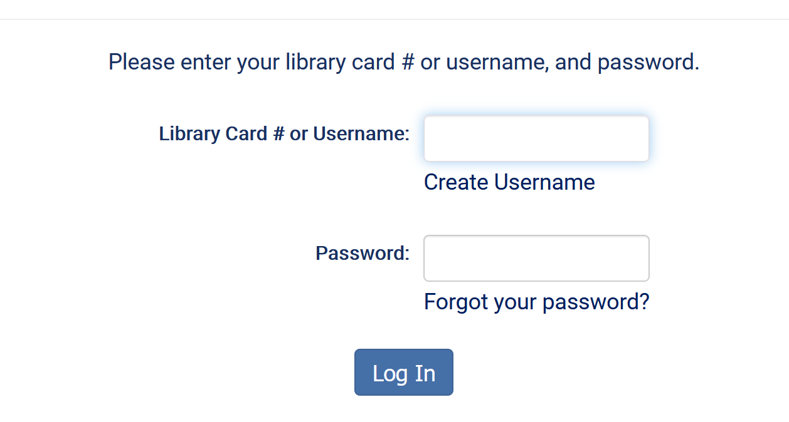

## Search Result

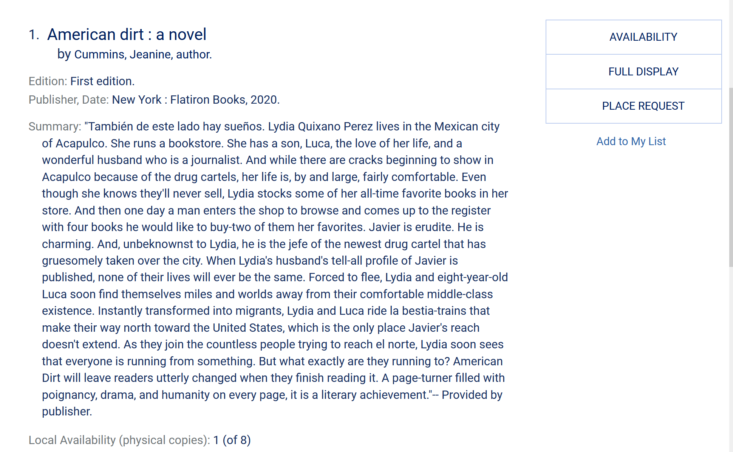

## Advanced Search

